**WEB REPORT**

**EnigmaSports.uz**

-Make your body feel alive !

-Making collection with careful approach !

-Combination of fashion and sport !



**url to our host:** [**sportenigma.000webhost.com**](http://sportenigma.000webhost.com/)

**TEAM Members:**

**Jasurbek Davronov U1610096**

**Murad Mirzayev U1610160**

**Islombek Tokhirov U1610084**

**Jasurkhon Mahmutkhojaev U1610097**

**Jamoliddin Alavitdinov U1610091**

Founded in August of 2017, based in Tashkent, Uzbekistan, relatively young Enigma Sports Apparel e-shop, within a short period, became one of the most trusted community marketplace among others in the region. Taking only the best from other apparel shops, our fellow workers tried their best to create something unique and inimitable, and somehow did it.

Our company offers such a variety of wears and gears, that no matter where you are or where you go, our product will never ever fail you, whether you are a free runner, skier or just love to experience extreme and adrenaline through your veins.

Now we are have partnership with mainly Adidas, Lacoste, Powerhouse-fitness. we know these brands are world famous, but we are not going to stay on track. We are looking forward to become a partner other worldwide brands.

As our company was founded in Tashkent, for now it offers its services for central Asian region, but it was already planned to spread our services and products not only to whole Asian region, but all across the world, and, we hope, with such an amazing community by our side, it won't make any issue for us.

Here are some screenshots from our web shop

**-wardrobe for life**

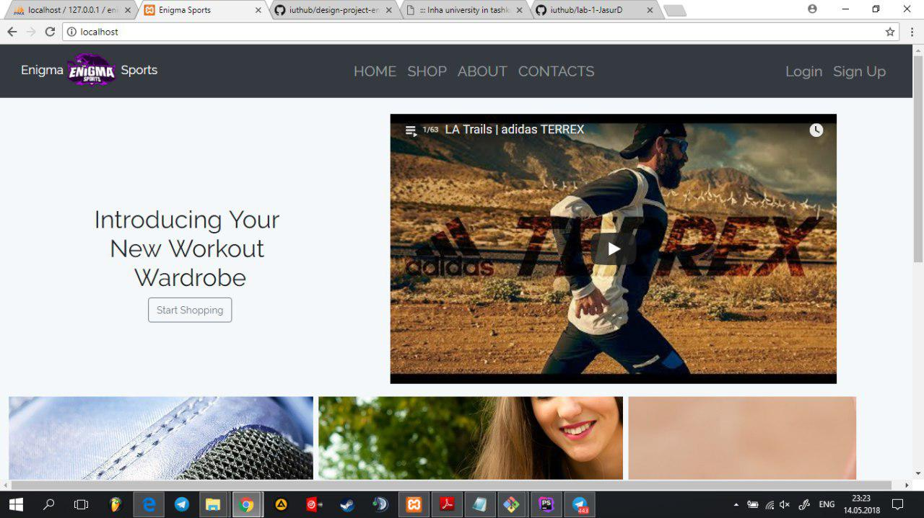

The main page contains the introducing trailer from Adidas official channel (we have used YouTube API) and recommend guest to see our product through the shop, Also the main page has the header and footer with appropriate menus.

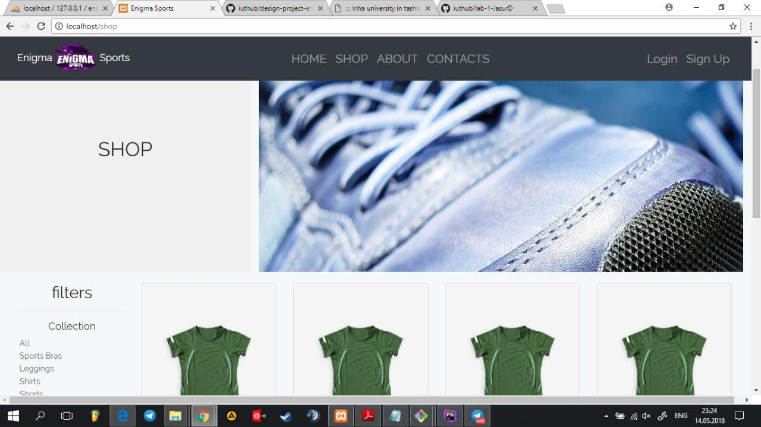

The shop page consist of latest product of company and give a filters to user to choose appropriate one through recommended. You can click to product card to see detailed information about it. Also each of the product are read from database "products" and loaded to shop view

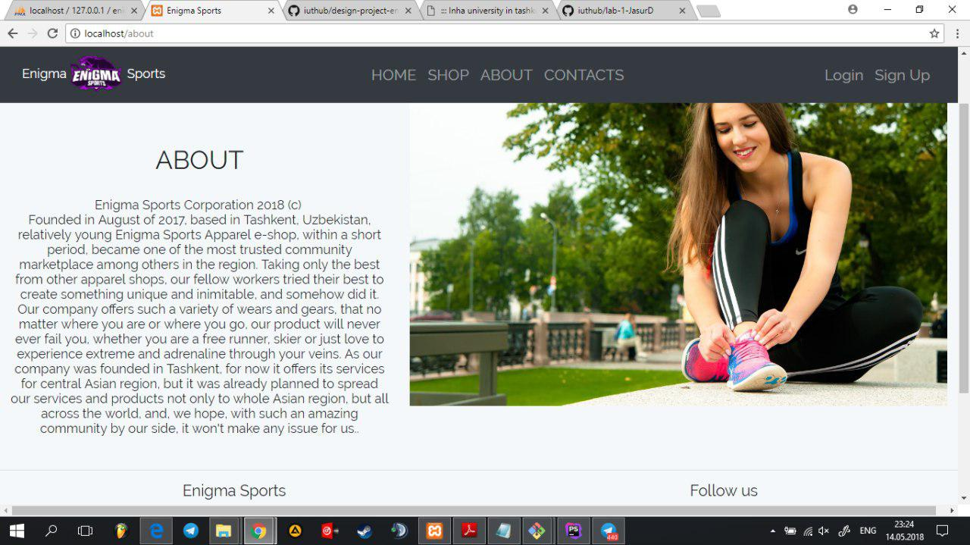

About page shows the overview information about our company activity, goals, and achievements. You can read a bit info about how this company started his activity and what is going on today. You also recommended go through links given in footer side to follow us in social groups like Facebook, Telegram

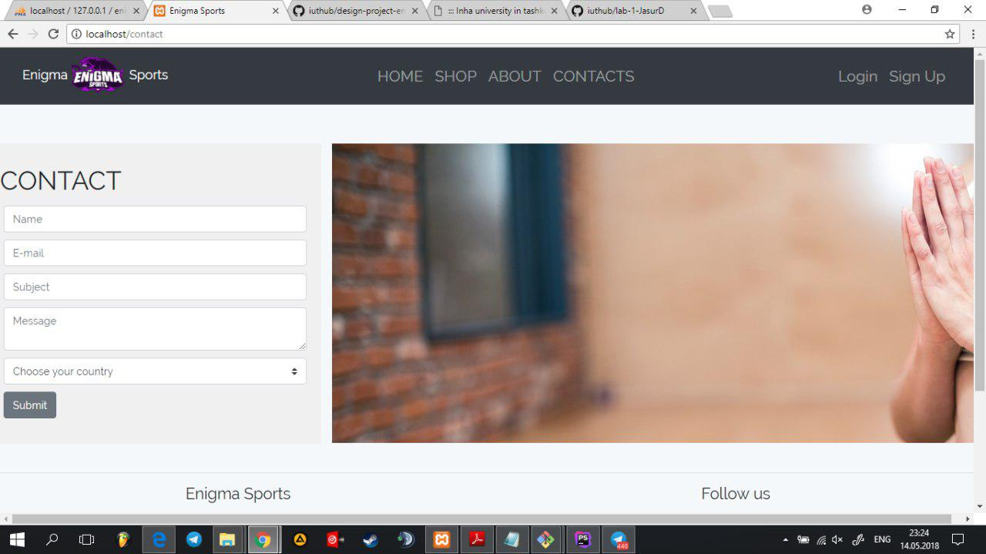

In the contact page you can leave any complaint or feedback about our site, product at all. Feel free to do it because our company puts clients interest in first position than of course its products quality. Anyway leave a some info about you and we will be thank for you.

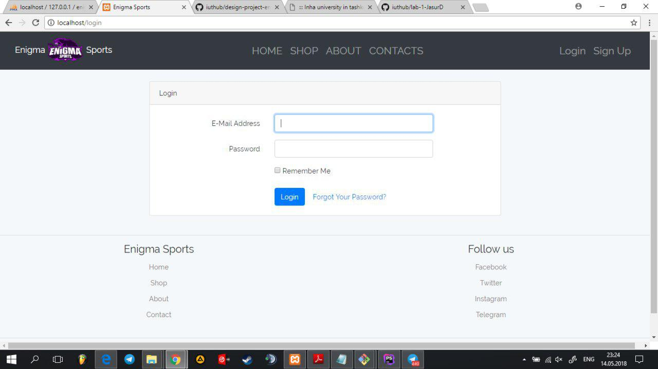

Appropriate Login form where you can log in into the system. Email address format is checked on client-side (regex) and also in server side (making sure that this credentials are not fake). Password at least must be 6 characters.

If you are a new user you can easily Register in our site. All your information about account stored in "users" database table.